**Sander VanWilligen – Homework 7 Report:**

**Problems 1 and 2:**

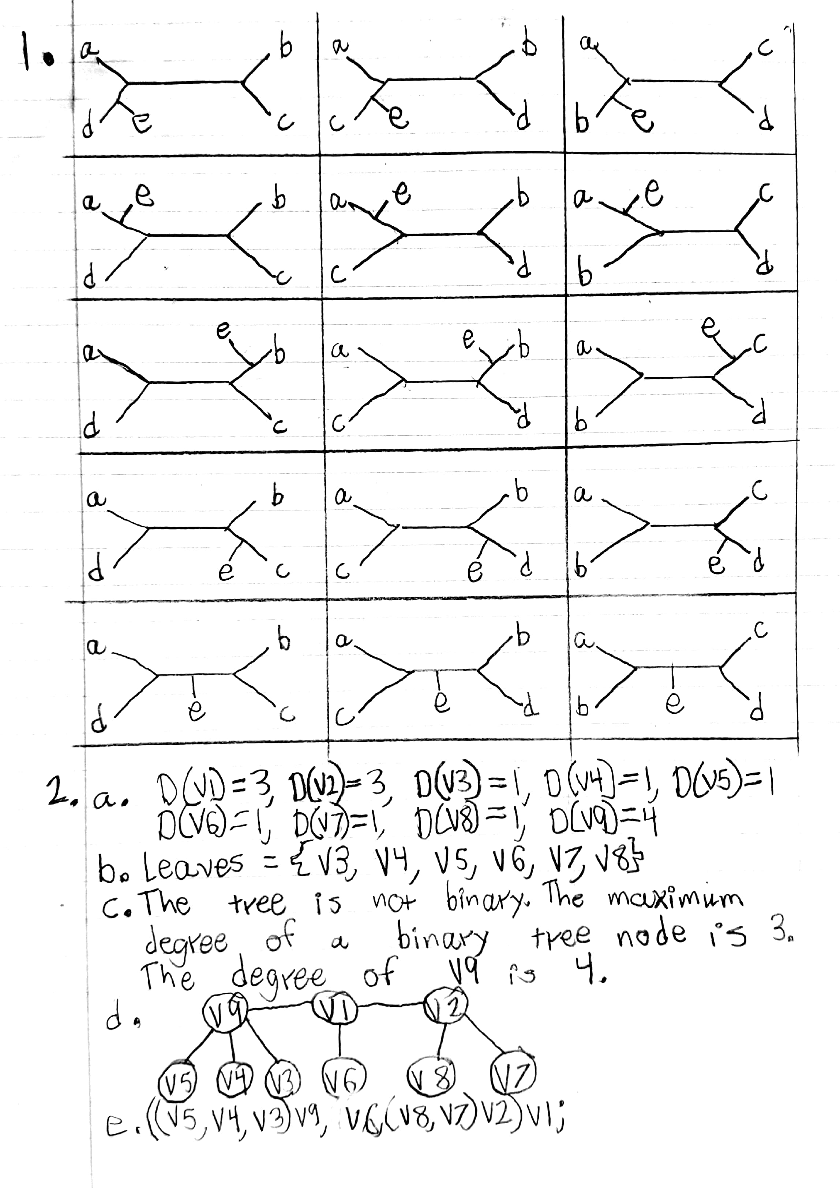

**Problem 3:**

When using the program on problem 2 part e, it does not produce the same result. The tree from problem 2 is an unrooted non-binary tree with internal and leaf nodes. The program produces a binary tree and treats all nodes as leaf nodes

**Problem 4:**

Distance between dog and cat is: 0.146808432845

Distance between dog and mouse is: 0.146808432845

Distance between dog and pig is: 0.107325632731

Distance between dog and human is: 0.329524994838

Distance between cat and mouse is: 0.232616196228

Distance between cat and pig is: 0.107325632731

Distance between cat and human is: 0.383119217824

Distance between mouse and pig is: 0.146808432845

Distance between mouse and human is: 0.383119217824

Distance between pig and human is: 0.383119217824

**Problems 5 and 6:**

Next page

